CS3402 Tutorial 1:

1. Below are some sample data stored in an Excel file.
2. Identify *entity*, *entity set*, *attribute*, *relationship*, *relationship set* in this application.
3. Is there any *integrity constraint* in this application? If so, is it possible or easy to make sure the constraint(s) is not violated in Excel?

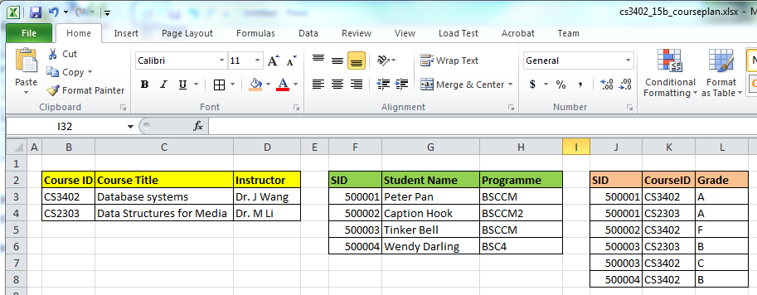

1. Construct an ER diagram for a car insurance company with a set of customers, each of whom owns a number of cars. Each car has a number of recorded accidents associated with it.
2. Construct an ER diagram for a hospital with a set of patients and a set of medical doctors. A log of the various conducted tests and results is associated with each patient.